**Service connection:** For connecting with other services.

For AWS> Access key and secrete key

For SonarCloud> Sonarcloud token

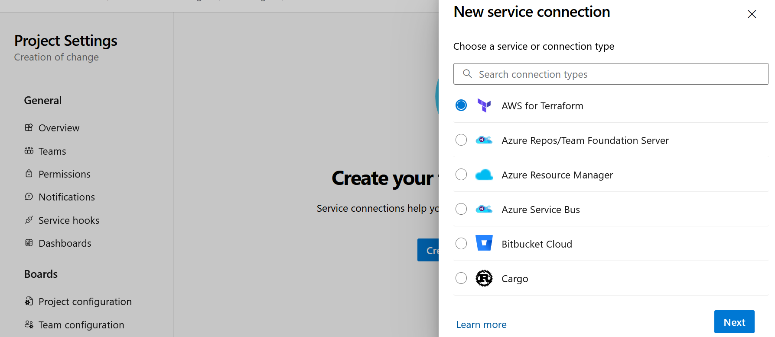

**Service principle:**

In Azure, a Service Principal is a security identity used by applications, automated tools, and services to access Azure resources securely. It works like a user identity but is meant for applications and scripts rather than human users.